**PROJECT REPORT**

**CMPE-257 - MACHINE LEARNING**

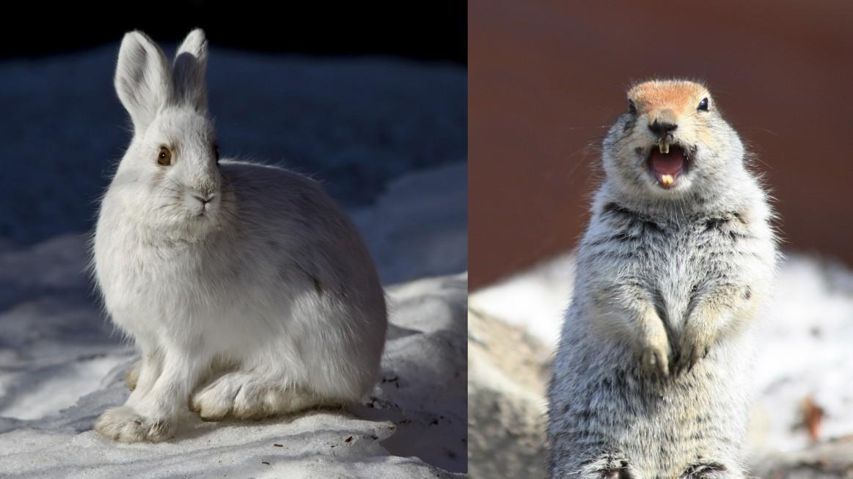

**Submitted By: Group 7**

**Team Members:**

**Qiao Liu - 013802893**

**Ching-Min Hu - 013726154**

**Dandan Zhao - 013795392**

**Fernanda Bordin - 013800638**

**Megha Rajam Rao - 013709488**

**Rajasree Rajendran - 013774358**

**Selected ML Algorithm: K-Nearest Neighbors**

**Google Colab link:**

# Task Assignment

|  |  |  |
| --- | --- | --- |
| Task | Description | Names |
| Data Preparation | Load, pre-process and visualize data | Megha Rajam Rao |
| ML methods | KNN classifier, Bagging classifier | Dandan Zhao  CHING-MIN HU  Fernanda Bordin |
| Neural networks | Dense(feedforward) and Densenet121 - failed experiment. | Fernanda Bordin |
| Neural Networks | Convolutional Neural Network - failed experiment. | Qiao Liu  Rajasree Rajendran |
| Powerpoint presentation | Input on Neural network  Input on Data preparation  Input on ML algorithms  Input on CNN | Fernanda Bordin  Megha Rajam Rao  Dandan Zhao, CHING-MIN HU  Qiao Liu, Rajasree Rajendran |
| Report (contributors) | Input on Data Preparation  Input on Neural network, overall analysis, KNN  Input on ML algorithms  Input on CNN | Megha Rajam Rao  Fernanda Bordin  Dandan Zhao, CHING-MIN HU  Rajasree Rajendran, Qiao Liu |

**TABLE OF CONTENTS**

Task Assignment 2

**Introduction** 4

**Libraries** 4

**Softwares & Tools** 4

**Procedure** 5

**Models results overview:** 5

**Data Preparation:** 6

**Random Forest:** 8

**Confusion Matrix:** 10

**Classification Report:** 10

**Extra Decision Tree:** 10

**Confusion Matrix:** 12

**Classification Report:** 12

**Gradient Boosting:** 12

**Confusion Matrix:** 14

**Classification Report:** 14

**SVM with ‘rbf’ kernel:** 14

**Confusion Matrix:** 15

**Classification Report:** 16

**Logistic Regression:** 16

**Confusion Matrix:** 17

**Classification Report:** 18

**K-neighbors Classifier:** 18

**Confusion Matrix:** 20

**Classification Report:** 20

**Bagging Classifier**: 21

**Confusion Matrix:** 23

**Classification Report:** 23

**Overall analysis**: 24

**Challenges faced:** 26

**The failed experiments:** 26

**Conclusion:** 28

**References** 29

# **Introduction**

The CIFAR datasets are labeled subsets of the 80 million tiny images dataset collected by Alex Krizhevsky, Vinod Nair, and Geoffrey Hinton. The images are of size 32x32 pixels with 3 color channels (RGB). It comprises of 100 classes containing 600 images each (500 training and 100 testing). The classes (fine labels) are grouped into 20 super classes (coarse labels) and corresponding classes. In this report we filtered the CIFAR-100 dataset to select images from the super classes we chose, which are medium-sized mammals and small mammals.

The medium-sized mammals superclass includes the following classes:

fox, porcupine**,** possum, raccoon, skunk.

Small mammal’s superclass includes the following classes:

Hamster, mouse, rabbit, shrew, squirrel.

# **Libraries**

1. Numpy
2. Pandas
3. Keras
4. Sklearn
5. Matplotlib
6. Tensorflow
7. Math
8. Time
9. Seaborn

# **Softwares & Tools**

1. Google Colaboratory
2. Python (language)
3. Powerpoint (presentation)
4. Word (report)
5. Google drive (document sharing)

# 

# 

# 

# 

# 

# 

# **Procedure**

## **Models results overview:**

|  |  |  |
| --- | --- | --- |
| MODEL | MILESTONE1_SCORE | MILESTONE2_SCORE |
| K-neighbors Classifier | 61.3% | 50.92% with 'n_neighbors': 8, 'weights': 'distance' |
| Bagging Classifier | 62.9% | 50.83% with 'bootstrap': False, 'bootstrap_features': False, 'max_samples': 0.01, 'n_estimators': 3 |
| ExtraTree Classifier | 67% with 'max_depth': 30, 'n_estimators': 500 | 48.5% with 'max_depth': 15, 'n_estimators': 180 |
| RandomForest Classifier | 65.60%with 'max_depth': 30, 'n_estimators': 500 | 48.17% with'max_depth': 15, 'n_estimators': 80 |
| GradientBoosting Classifier | 65.8% | 47% with ‘learning_rate': 0.1, 'max_depth': 10, 'n_estimators': 20 |
| SVM kernel = “rbf” | 63.5% with C=10 | 42.5% with 'C' : 1, 'gamma' : 0.01 |
| Logistic Regression Classifier | 59.6% | 44.75% with 'C': 100, 'penalty': 'l2' |
| Neural Network (Feed Forward) | 61.51% | 50 % |
| Convolutional Neural Network (experiment 1) | 74.10% | 50% |
| CNN (experiment 2) | 76.18% |  |

After careful analysis of Milestone 1 results, we selected the ML algorithms which showed better performance to do the Milestone 2. We used the **GridSearch** method to tune the parameters of the model and got the best parameters, which showed better accuracy. They are:

* Extra decision tree
* Random forest
* Gradient boosting
* SVM with ‘rbf’ kernel
* Bagging
* Logistic regression.

From the accuracy, most of the Machine Learning methods are not so good and showed little consistency between milestones.

**KNN** was the most consistent algorithm and had the best performance both in accuracy and running time, with **Bagging classifier** being a close second in performance. We ran a full analysis for KNN method, while exploring the most relevant aspects for Bagging.

## **Data Preparation:**

* Since we already extracted the assigned super classes (small mammals and medium-sized mammals), we used the same filtered data to begin with the Milestone 2. In order to achieve the Milestone 2 goals, we are selecting smaller subsets of data containing fewer sub-classes for training and testing.
* The sub-classes in bold format are used for initial training whereas the two excluded ones are used for testing.

Medium-sized mammals: fox, **porcupine, possum, raccoon, skunk.**

Small mammals: **hamster, mouse, rabbit, shrew,** squirrel.

Index of Medium-sized mammals: [34, 63, 64, 66, 75]

Index of Small mammals: [36, 50, 65, 74, 80]

* Sub-classes were selected for training and testing each combination. This was done by defining a function for selecting train/test sub-classes. Training set was created by extracting the index of **fine_labe**l from **medium_sized_mammals** list and **small_mammals** and combining them to **target_ind**. Testing data was created by splicing the dataset to extract the relevant data.

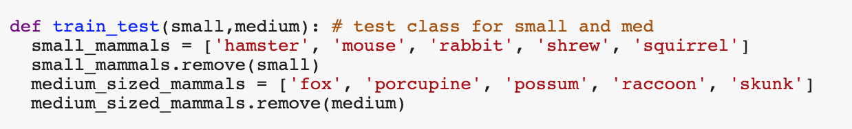

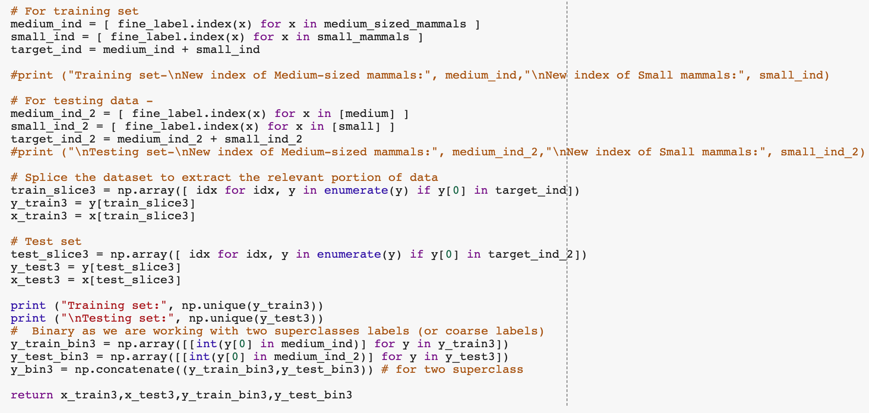

* A list was created for the train and test set by indexes using loops. The output indexes confirmed that data selected was the relevant data.

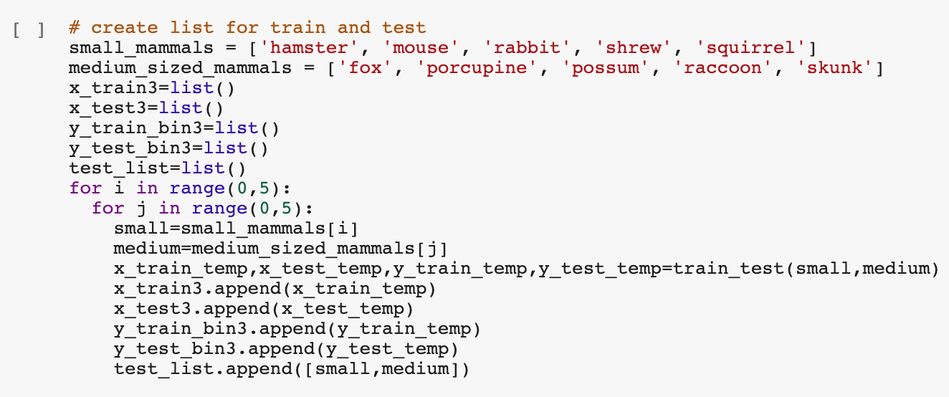

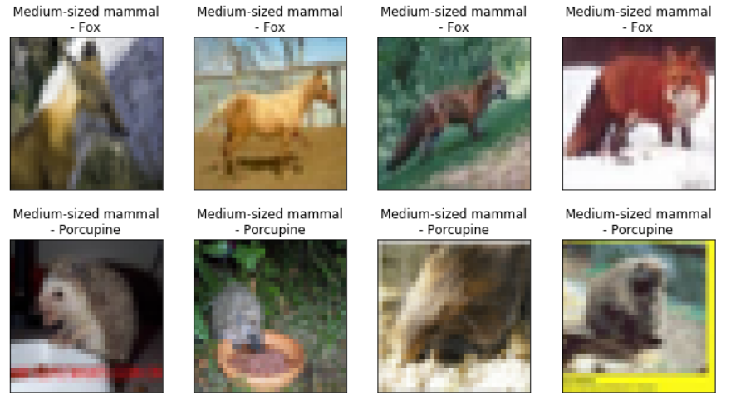

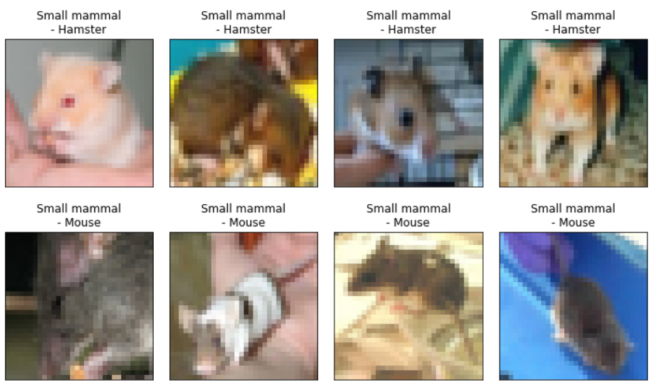

* Once the dataset was validated and ready, we proceeded ahead with the algorithms.

## 

Analyzing the results of Milestone 1, we decided to test the algorithms which showed good results for Milestone 1, in Milestone 2 as well. As the first step, we tried Random Forest Classifier.

## **Random Forest:**

* The model was defined and built, then fit using training data. The prediction was generated using ***.predict()*** and performance was evaluated by finding the score.

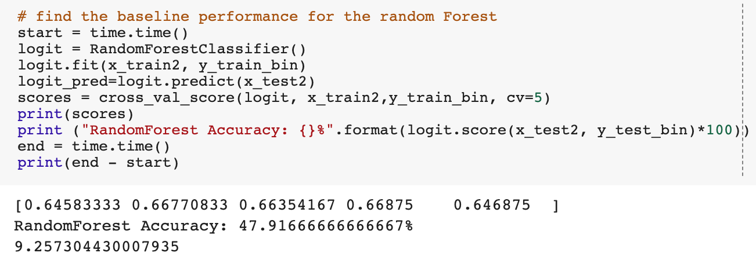

The prediction score on testing data with best estimator was found to be 48.17%.



The predicted data can be seen here:

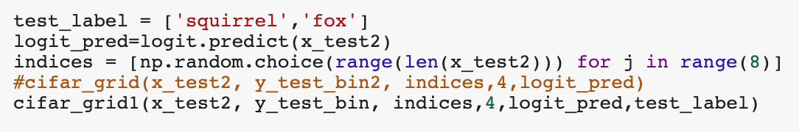

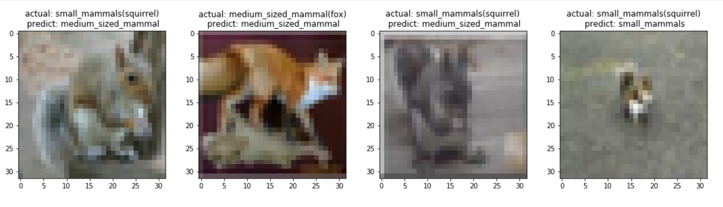

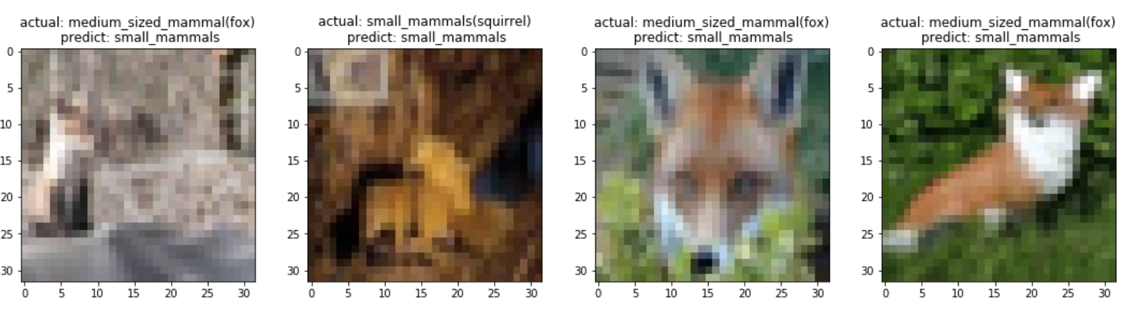

### **Confusion Matrix:**

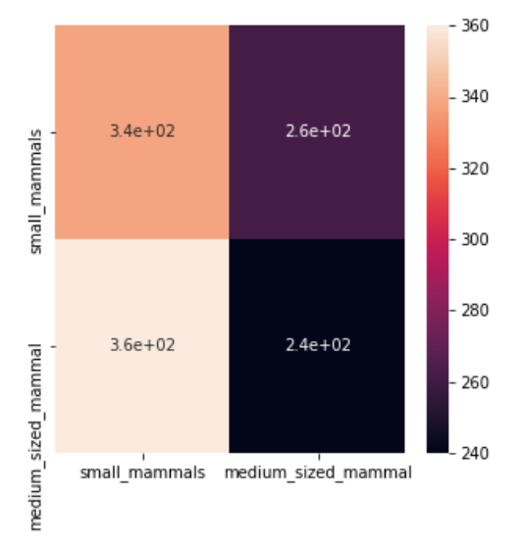

## 

### **Classification Report:**

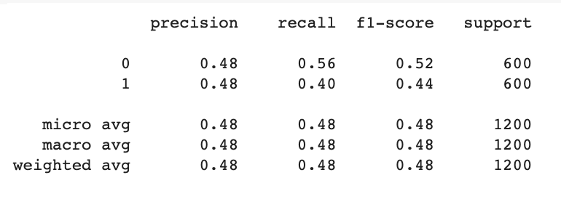

We moved on to the next method since this did not provide much accuracy. The next method we tried was Extra Decision Tree method.

## **Extra Decision Tree:**

* The model was defined and built, then fit using training data. The prediction was generated using ***.predict()*** and performance was evaluated by finding the score.

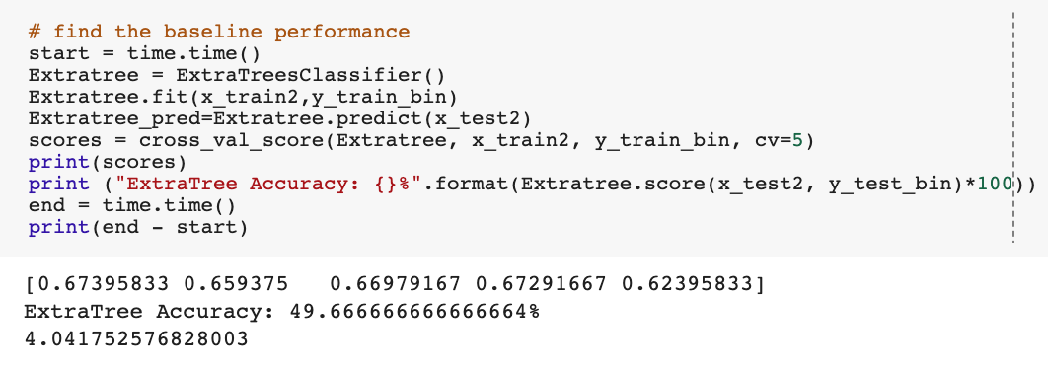

The prediction score on testing data with best estimator was found to be 48.50%.



The predicted data can be seen here:

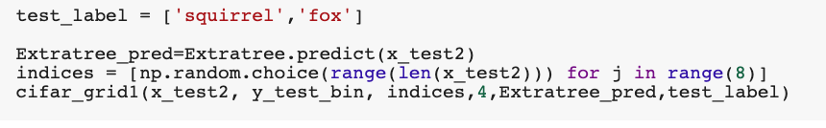

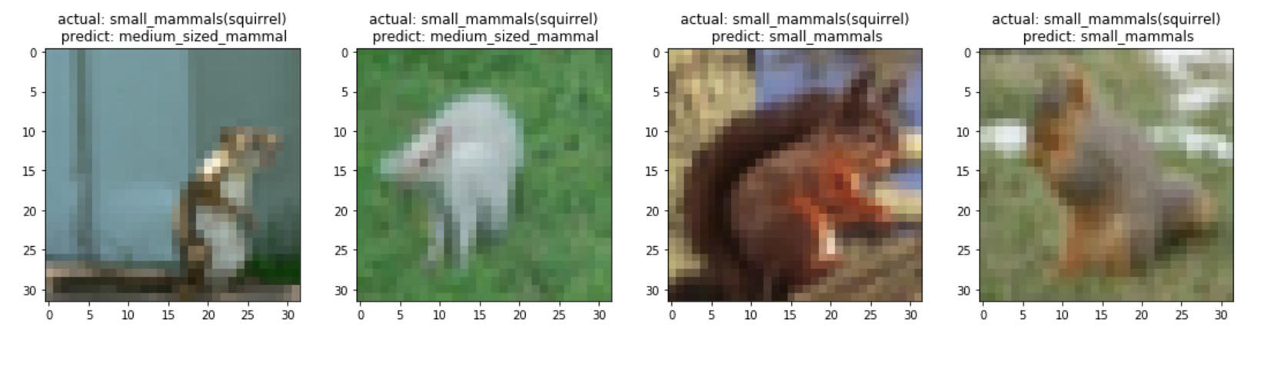

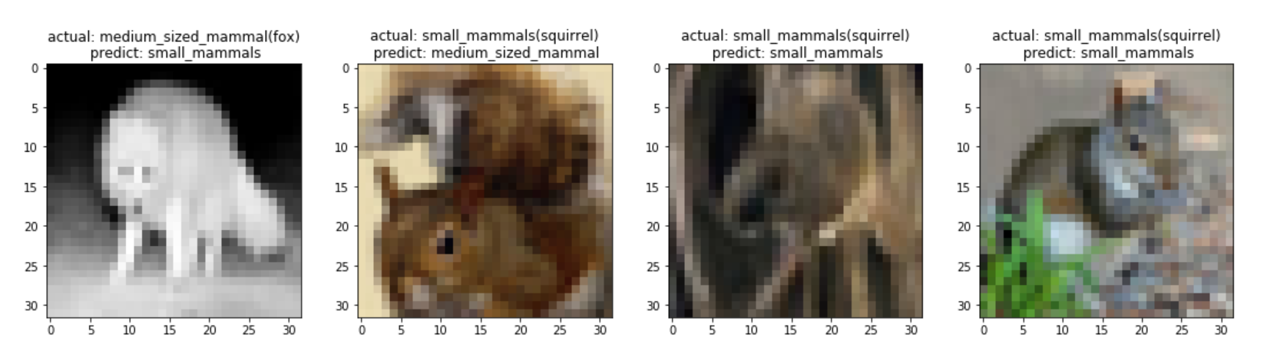

### **Confusion Matrix:**

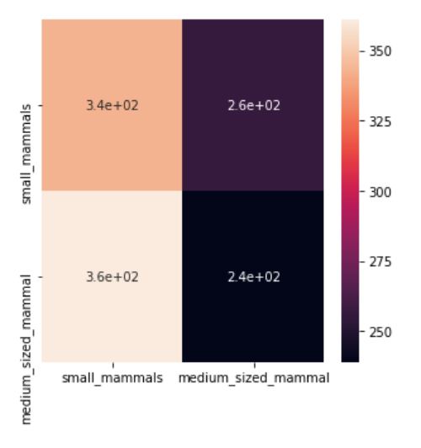

### **Classification Report:**

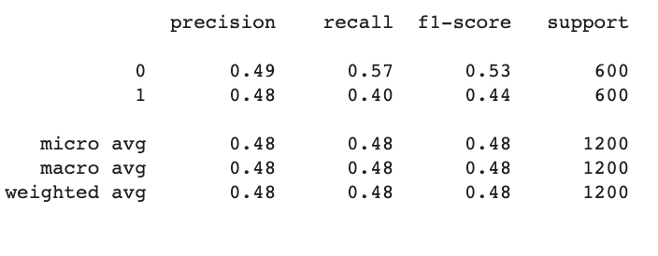

Since this was again not giving better results, we tried Gradient Boosting algorithms.

## **Gradient Boosting:**

* The model was defined and built, then fit using training data. The prediction was generated using ***.predict()*** and performance was evaluated by finding the score.

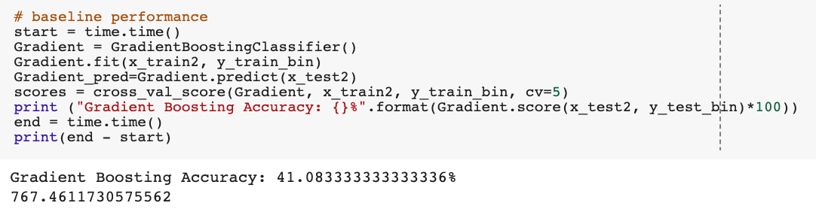

The prediction score on testing data with best estimator was found to be 47.00%.



The predicted data can be seen here:

## 

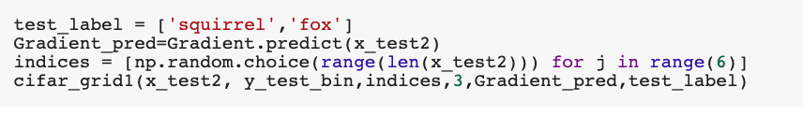

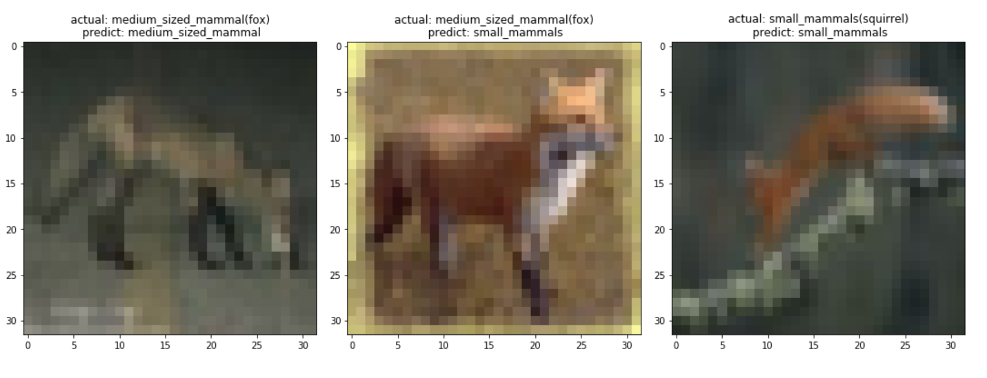

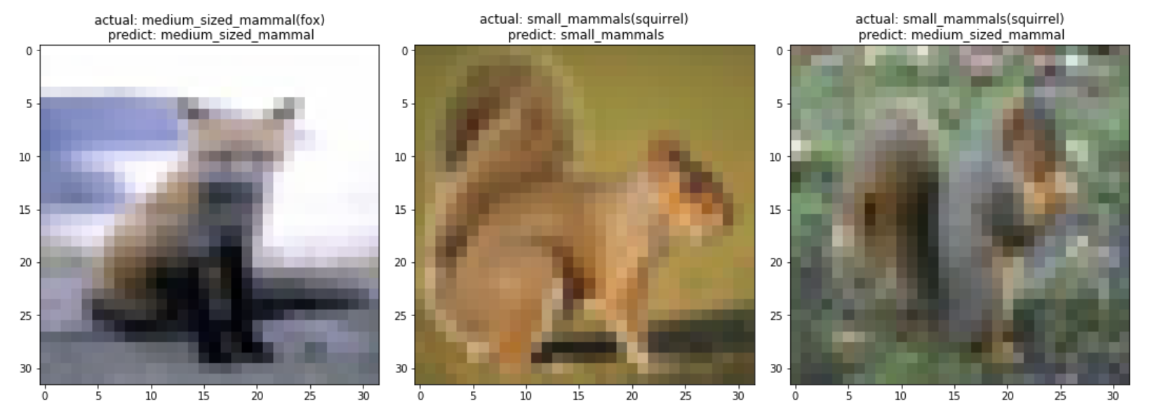

### **Confusion Matrix:**

## 

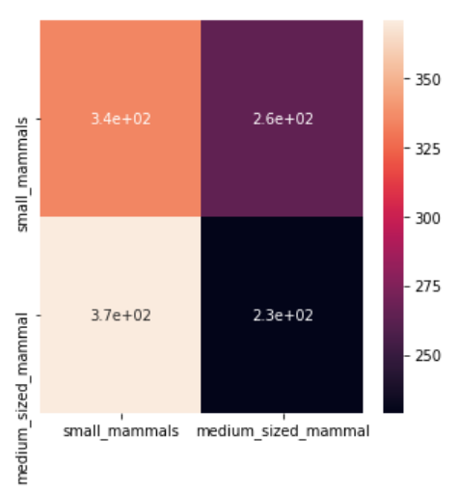

## 

### **Classification Report:**

Due to the low accuracy score, we moved on to the next algorithm - SVM with ‘rbf’ kernel.

## **SVM with ‘rbf’ kernel:**

* The model was defined and built, then fit using training data. The prediction was generated using ***.predict()*** and performance was evaluated by finding the score.

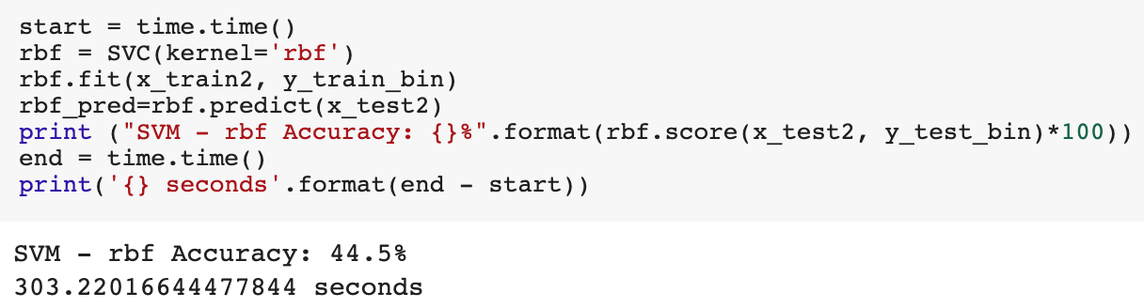

The prediction score on testing data with best estimator was found to be 42.50%.



The predicted data can be seen here:

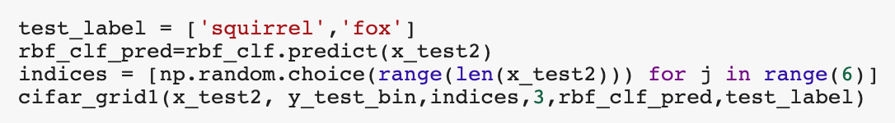

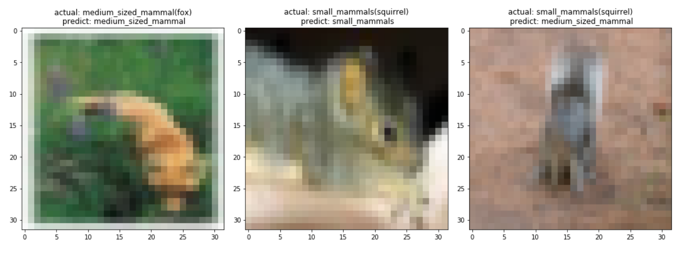

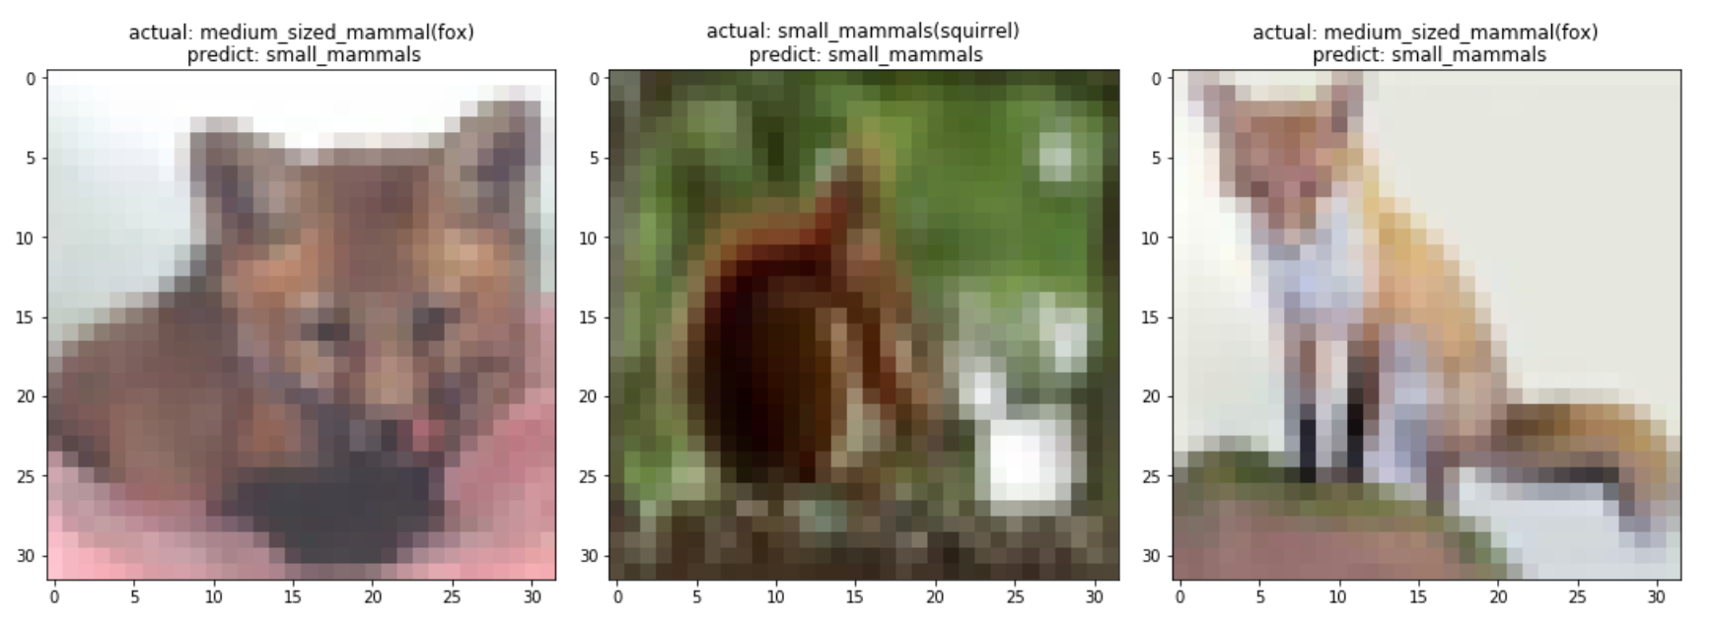

### **Confusion Matrix:**

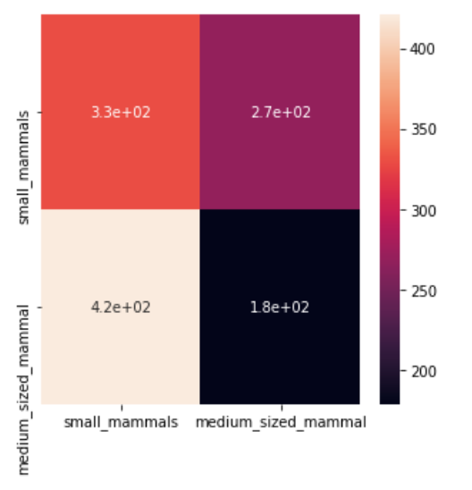

### **Classification Report:**

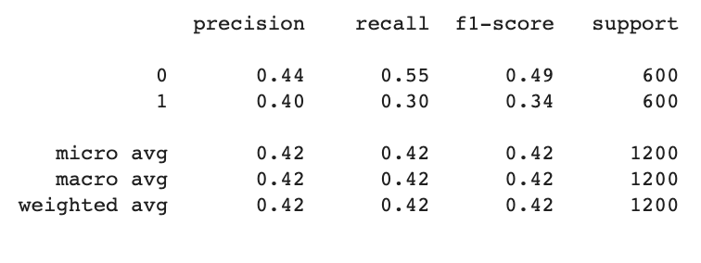

## 

Hoping that logistic regression will give better results, we tried that.

## **Logistic Regression:**

* The model was defined and built, then fit using training data. The prediction was generated using ***.predict()*** and performance was evaluated by finding the score.

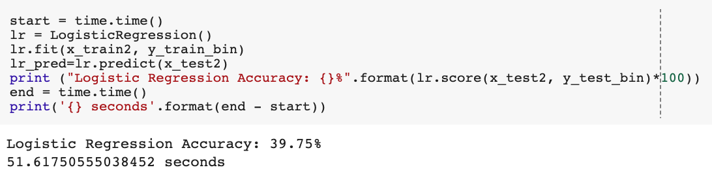

The prediction score on testing data with best estimator was found to be 44.75%.



The predicted data can be seen here:

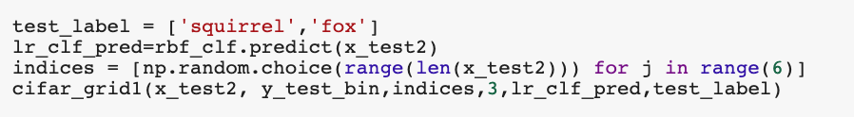

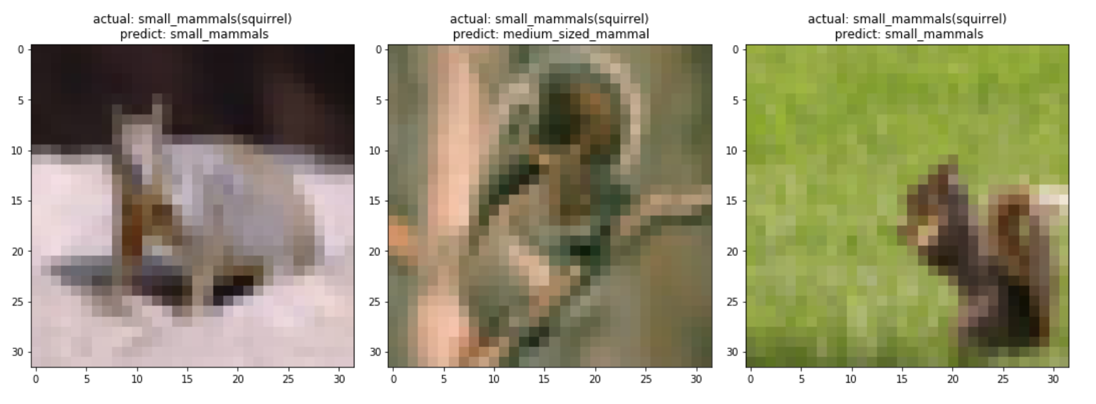

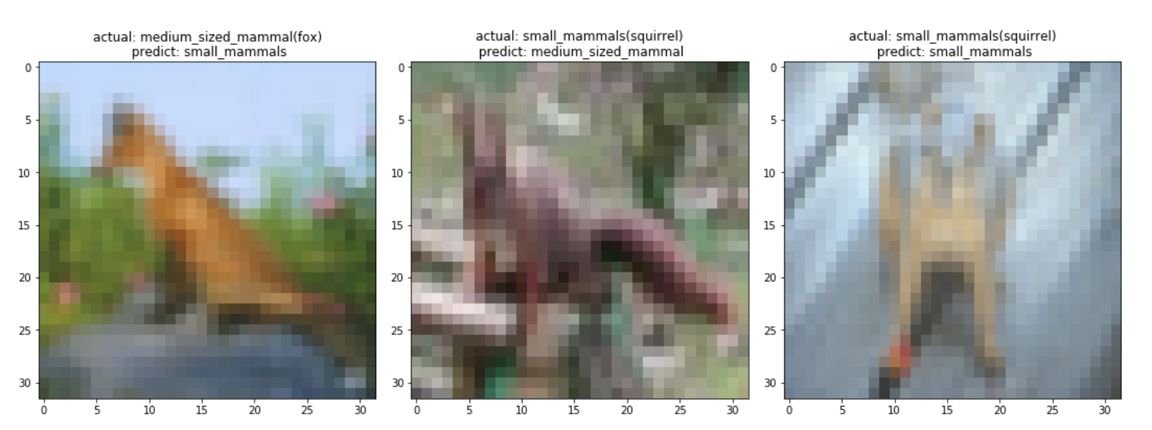

### **Confusion Matrix:**

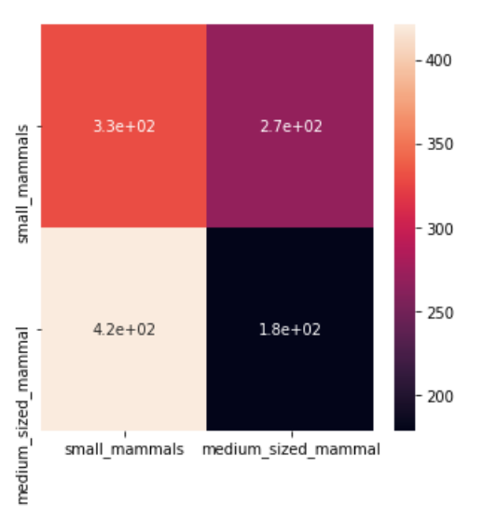

## 

### **Classification Report:**

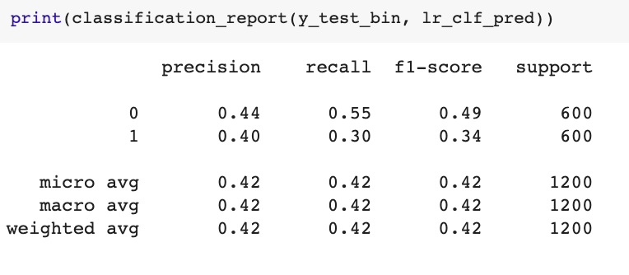

## **K-neighbors Classifier:**

* The model was defined and built, then fit using training data. The prediction was generated using ***.predict()*** and performance was evaluated by finding the score.

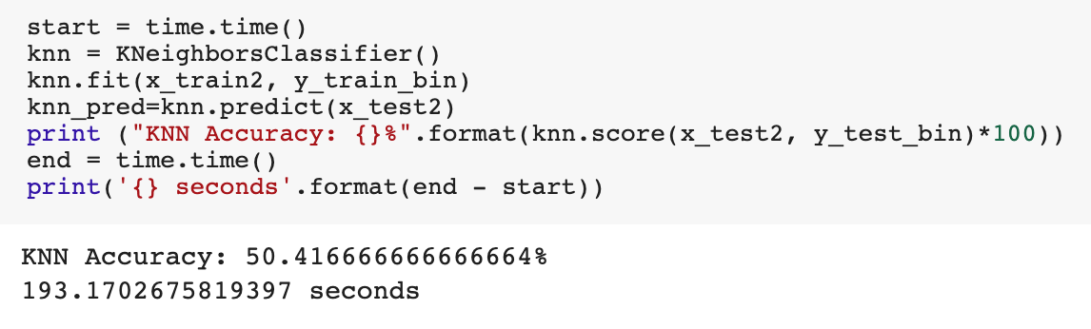

The prediction score on testing data with best estimator was found to be 50.92%.



The predicted data can be seen here:

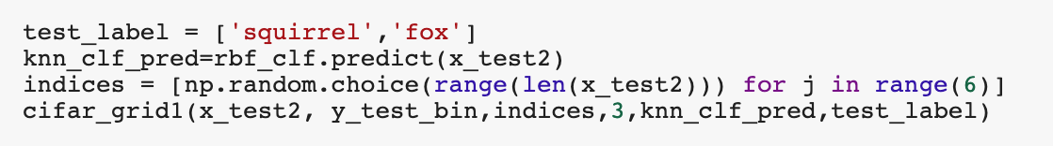

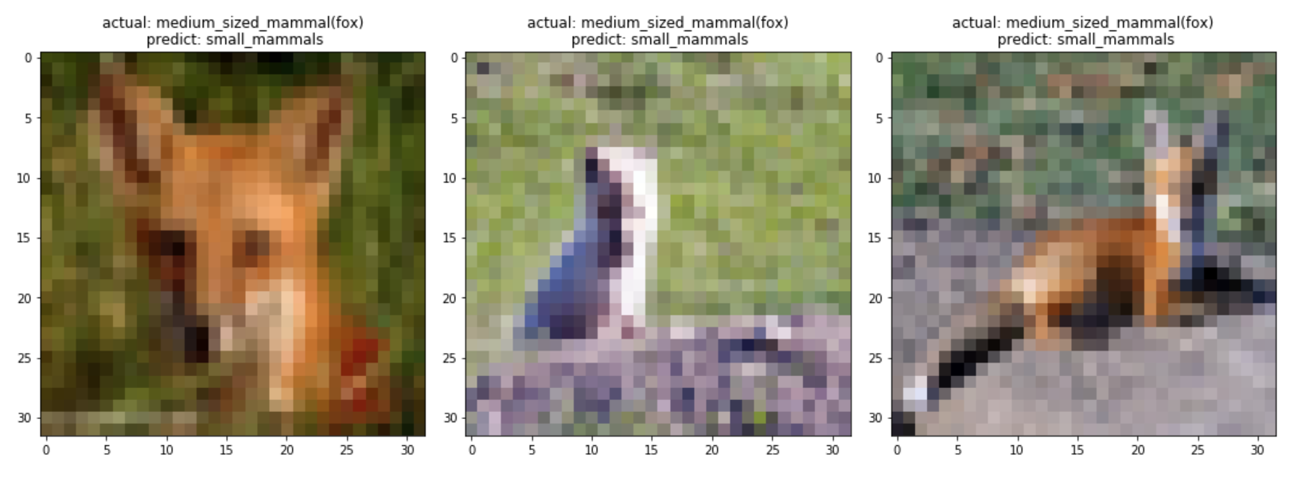

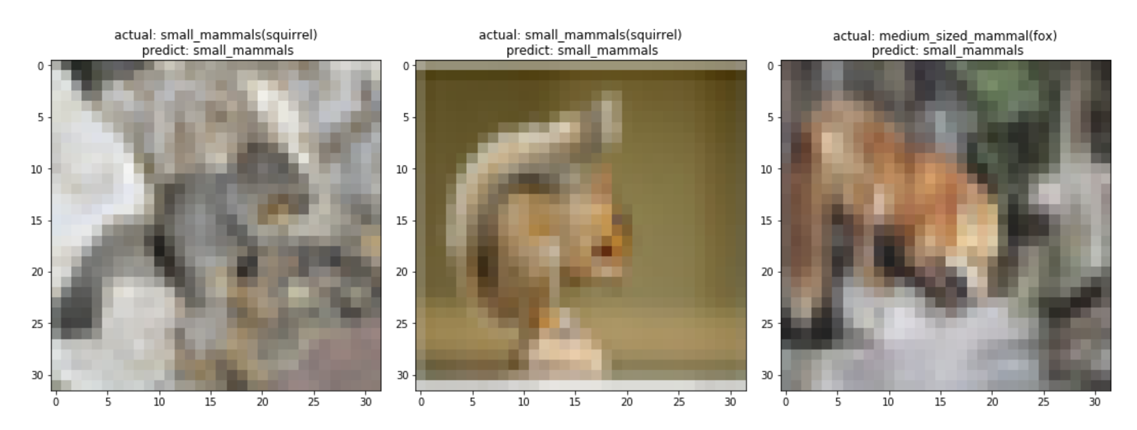

### **Confusion Matrix:**

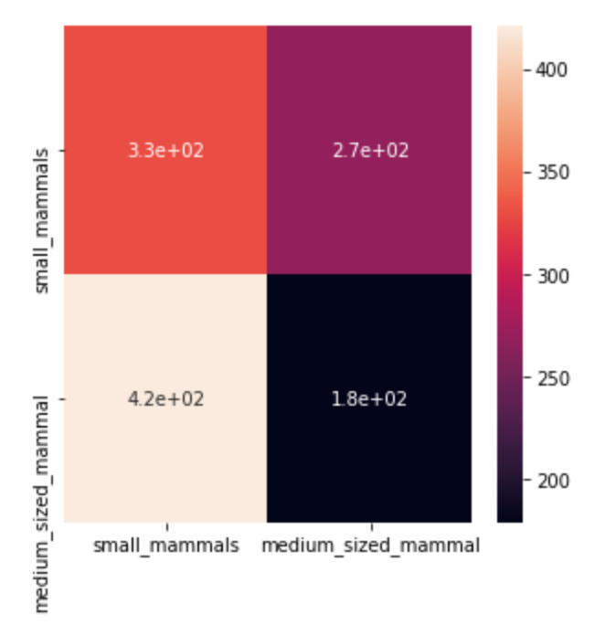

### **Classification Report:**

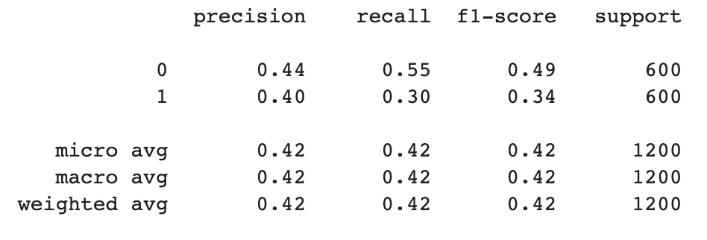

The model was run to find the accuracy score of different combinations using a function.

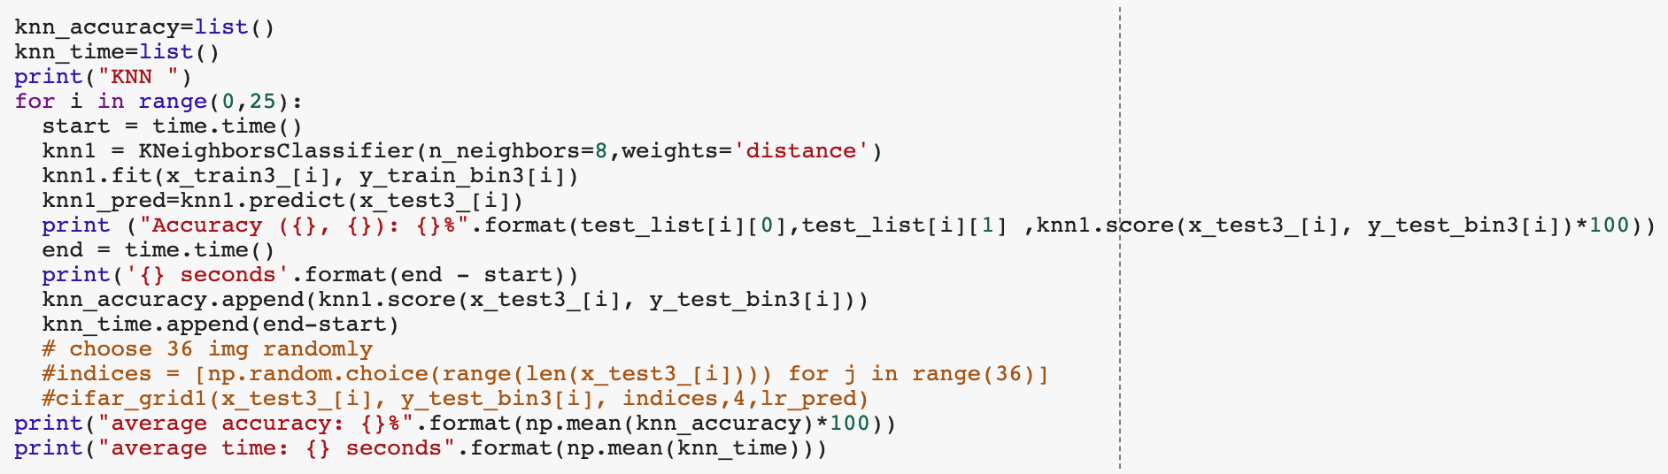

The resulting scores for each combination can be seen from the following table.

|  |  |  |  |  |  |  |
| --- | --- | --- | --- | --- | --- | --- |
| **K-neighbors** | Fox | Porcupine | Possum | Raccoon | Skunk | AVERAGE |
| Hamster | 53.08% | 56.41% | 56.92% | 53.75% | 53.34% | 54.70% |
| Mouse | 49.92% | 54.92% | 54.83% | 52.83% | 52.00% | 52.90% |
| Rabbit | 48% | 55.00% | 55.75% | 52.00% | 52.17% | 53% |
| Shrew | 43.25% | 50.16% | 50.58% | 49.00% | 49.58% | 48.51% |
| Squirrel | 50.67% | 56.33% | 56.16% | 54.83% | 54.08% | 54.41% |
| AVERAGE | 48.92% | 54.56% | 54.85% | 52.48% | 52.23% | 52.61% |

K-neighbors had the best overall score (52.61%), with its best individual score being 56.92% (in this iteration). Results had the following characteristics:

* Best pairing: **Hamster & Possum (56.92%)**
* Worst pairing: **Fox & Shrew (43.25%)**
* Easiest class to predict: **Possum (54.85%)**
* Hardest class to predict: **Shrew (48.51%)**

It becomes clear that there is a relation between the pairing being used as test, the easiness to predict that class and the model’s performance.

## **Bagging Classifier**:

As the next step, we tried Bagging classifier. This was done by defining and building, then fitting using training data. The prediction was generated using ***.predict()*** and performance was evaluated by finding the score.

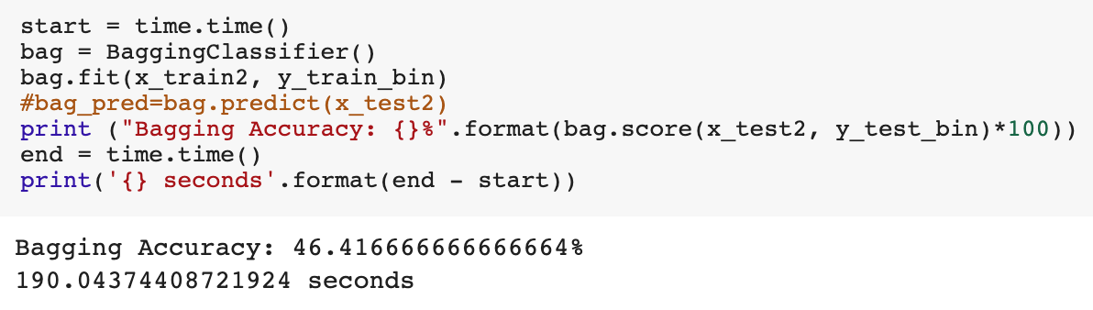

The prediction score on testing data with best estimator was found to be 50.83%.



The predicted data can be seen here:

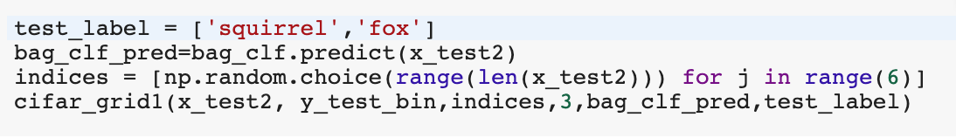

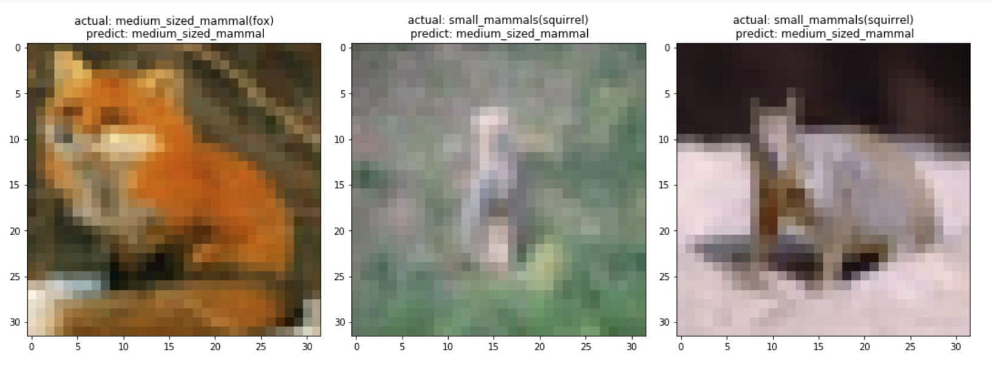

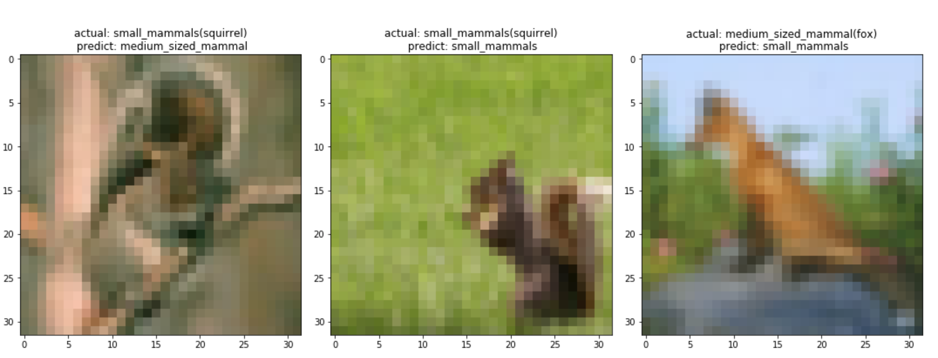

### **Confusion Matrix:**

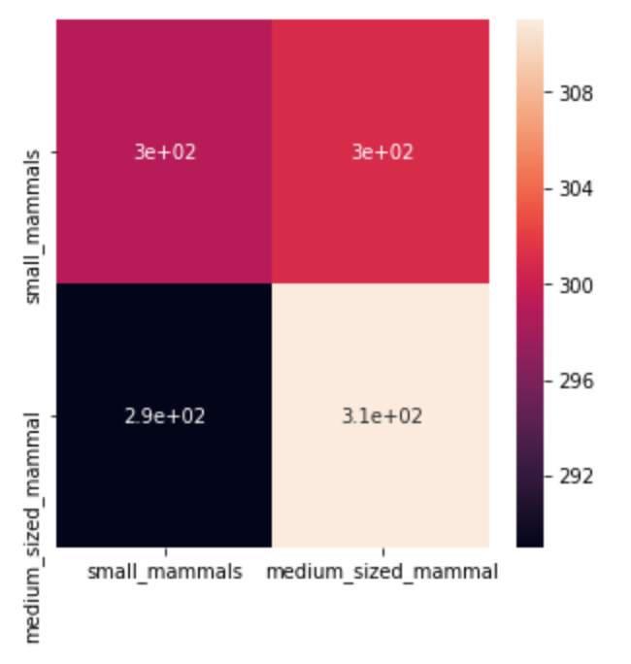

### **Classification Report:**

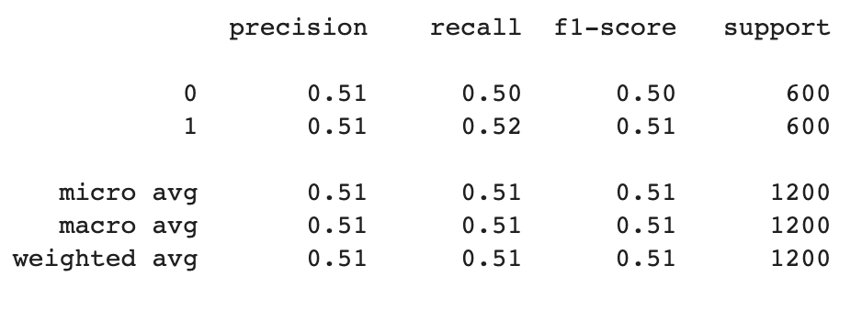

The model was run to find the accuracy score of different combinations using a function.

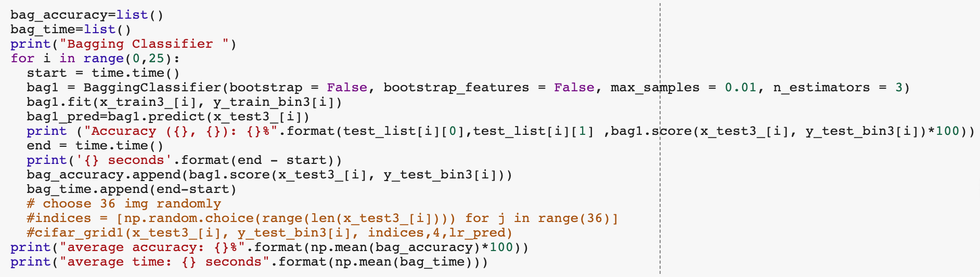

The resulting scores for each combination can be seen from the following table.

|  |  |  |  |  |  |  |
| --- | --- | --- | --- | --- | --- | --- |
| **Bagging** | Fox | Porcupine | Possum | Raccoon | Skunk | AVERAGE |
| Hamster | 58.09% | 48.09% | 62.33% | 50.84% | 47.50% | 53.37% |
| Mouse | 47.50% | 56.92% | 56.17% | 52.75% | 51.50% | 52.97% |
| Rabbit | 45% | 40.50% | 51.17% | 53.75% | 52.50% | 49% |
| Shrew | 43.84% | 46.75% | 49.50% | 47.67% | 51.17% | 47.79% |
| Squirrel | 47.50% | 50.84% | 50.58% | 49% | 49.58% | 49.50% |
| AVERAGE | 48.39% | 48.62% | 53.95% | 50.80% | 50.45% | 50.44% |

This classifier had a score of 59.05% for our standard pairing (Fox & Hamster). The average score was 50.44%.

Results had the following characteristics:

* Best pairing: **Hamster & Possum (62.33%)** → same as K-neighbors
* Worst pairing: **Rabbit & Porcupine (40.50%)**
* Easiest class to predict: **Possum (53.95%**) → same as K-neighbors
* Hardest class to predict: **Shrew (47.79%)** → same as K-neighbors

# **Overall analysis**:

Comparing the results from K-neighbors and Bagging, some similarities come to light.

In both cases the best result was obtained with **Hamster & Possum** as the testing sample, which was not the obvious answer once you look at their pictures. Personally, we expected the Skunk to have the best result given its very distinctive coloring.

Nonetheless this result is coherent with the rest of the results, since both Hamster and Possum ranked high their individual scores.

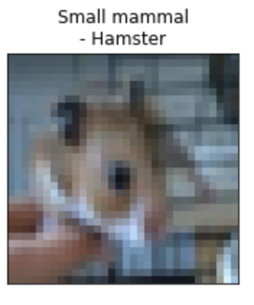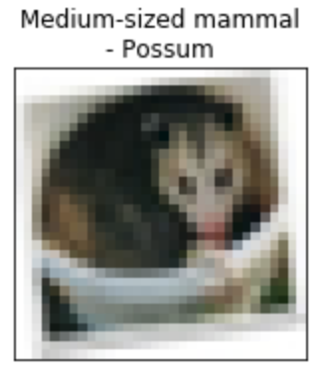

Different results were obtained as the worst pairing to predict **Fox & Shrew** **(K-neighbors)** and **Rabbit & Porcupine (Bagging)**.

Rabbit & Porcupine are indeed hard to distinguish, since there are many similarities once there is no size difference and the detail level is reduced to a point where one can no longer see the needles of the Porcupine.

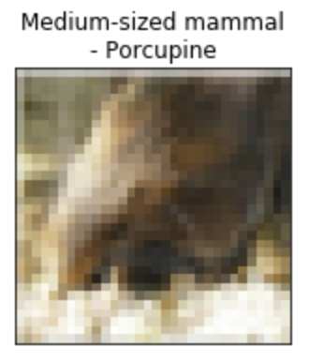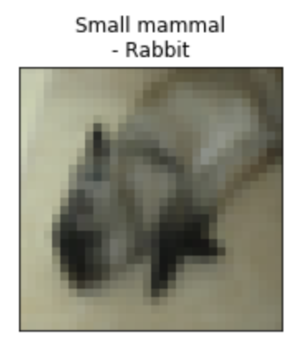

Once we look at Fox & Shrew, it is harder to understand, since both classes are very different from each other. Here we attribute the bad performance to the difficulty of predicting the species itself, Shrew was in both models the worst class to predict with Fox coming as a close second. Basically, we believe that Shrew and Fox are not being confused with each other, but with other species of the mega-classes.

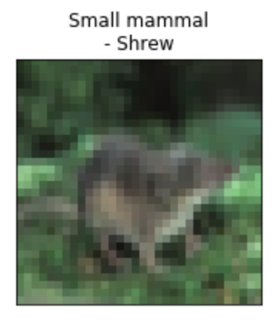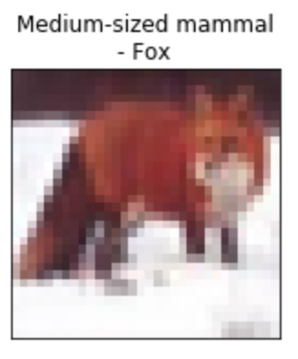

# **Challenges faced:**

## 

The data set proved to be one of the big challenges we had to face, with some of our classes being very alike and, in some cases, hard to tell apart even for humans.

One major aspect was that pictures were not to scale, with small or medium animals both occupying the same area of the image. Another was the pixilation of picture, which drastically reduced the level of details and in some cases made it impossible to know what it was.

# **The failed experiments:**

During milestone 2, we trained some other models with more than a hundred times trials totally, however, they did not reach our result of expectation. The models and the results will be shown below, some algorithms we compare their performance with the baseline (default parameters) to the best parameters after we tuned, some algorithms the best parameters performance even worse than baseline, which probably means they don't fit into this problem.

|  |  |  |
| --- | --- | --- |
| **Model** | **Baseline Performace** | **Score with best parameters** |
| **Random Forest** | **47.92%** | **48.17%** |
| **ExtraDecisionTree** | **49.67%** | **48.5%** |
| **Gradient Boosting** | **41.08%** | **47.00%** |
| **SVM with ‘rbf’** | **44.50%** | **42.50%** |
| **Logistic Regression** | **39.75%** | **44.75%** |

**Feedforward neural network:**

Feedforward proved to not be an effective way to analyze this dataset. After several attempts at making the model work, it would always predict the same class delivering a misleading result of 50% accuracy.

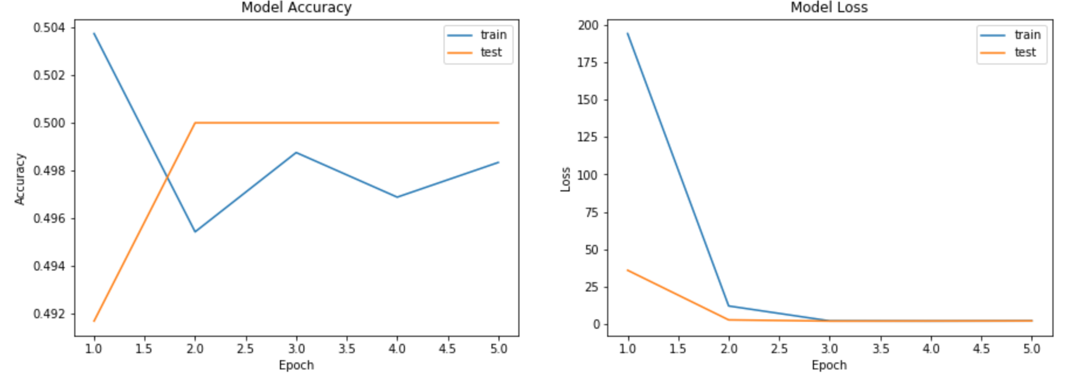

## 

## 

**DenseNet 121:**

Given its successful application to other parts of this dataset (other teams), we decided to explore its effectiveness in classifying mammals. Using as a basis the code from <https://www.kaggle.com/jutrera/training-a-densenet-for-the-stanford-car-dataset>, we applied it to our dataset. Running time increased a lot (over 10 minutes per epoch), which was expected since it runs consecutives models and has over 47 layers.

Unfortunately, we encountered a similar result as in feed forward network, with the model predicting only one type of class and getting a 50% accuracy score.

**CNN:**

Since we got excellent results with Convoluted neural Networks for our Milestone 1, we decided to try the same with this milestone as well. But unfortunately, we encountered the same fate as the Feedforward neural network and Dense121 network, we obtained only 50% accuracy score with the model predicting only one type of class.

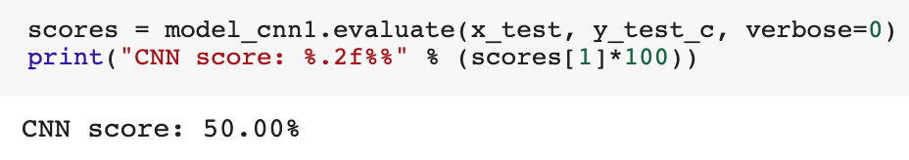

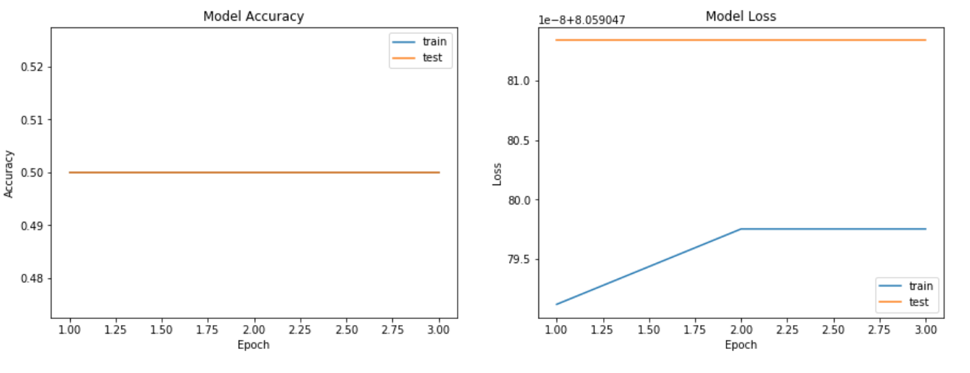

# **Conclusion:**

In this milestone, we used multiple algorithms to train models to recognize small sized mammals and medium sized mammals. During the project, we understood the importance of evaluating our model. By comparing training loss and testing loss, we can adjust the model to avoid overfitting. By looking at the confusion matrix and confusion report, we can infer the cause of our errors, and fine tune our model accordingly. The most important thing for a machine learning/deep learning model is not just a high score, but also robustness so it can predict for different cases.

For the milestone two (image classification for super classes: small and medium mammals) we selected **K- Nearest Neighbors** as the most promising, since it delivered a good score (50.92%) spending a reasonable amount of time processing (193.17s).

# 

# 

# 

# 

# 

# 

# 

# 

# 

# **References**

Berhane, F. (2016). *Deep Neural Network for Image Classification: Application*. From Data Scientist : https://datascience-enthusiast.com/DL/Deep-Neural-Network-for-Image-Classification.html

Kinli, F. (2018, September). *[Deep Learning Lab] Episode-5: CIFAR-100*. From Medium.com: https://medium.com/@birdortyedi_23820/deep-learning-lab-episode-5-cifar-100-a557e19219ba; <https://nextjournal.com/mpd/image-classification-with-keras>

[corochann](https://corochann.com/) (2017): *CIFAR-10, CIFAR-100 dataset introduction*

<https://corochann.com/cifar-10-cifar-100-dataset-introduction-1258.html>

Mohtadi Ben Fraj(Dec 21, 2017): *In Depth: Parameter tuning for Random Forest*

<https://medium.com/all-things-ai/in-depth-parameter-tuning-for-random-forest-d67bb7e920d>

[Aarshat J](https://www.analyticsvidhya.com/blog/author/aarshay/)ain (Feb 21, 2016): *Complete Guide to Parameter Tuning in Gradient Boosting (GBM) in Python*

<https://www.analyticsvidhya.com/blog/2016/02/complete-guide-parameter-tuning-gradient-boosting-gbm-python/>